**The Effects of Different Types of Music at Various Tempos on Teenagers’ Mood**

**Kai Hu**

**Introduction**

Our lives are full of music. Whether it is pop, classical, or rock, they are all essential to human’s everyday life. One study showed that adolescents listen to almost 21 hours of music per week (Gentile, Lynch, Linder, & Walsh, 2003). Even though people may spend a lot of time listening to music, people don’t always listen to only one genre of music. Different genres of music are often played on different occasions. For example, café jazz is usually played in a café where people are relaxing or studying, whereas classical music is often played when a mother is trying to coax her child to sleep.

Music also plays a role in affecting people’s moods. Moods are a result of the changes, whether it’s inhibition or release, in the neuroendocrine system. Although the causal relation between moods and different neurological disorders varies, they certainly are related. Based on a report from Center for Behavioral Health Statistics and Quality (CBHSQ) in 2014, 1 in10 older adolescents aged 16 to 17 had a major depressive episode (MDE) in the past year. Thus, the subjects for this research will be teenagers who are 16 and 17 year-old in order to investigate the music’s effects on the moods of this older teenage group.

Most previous research on the relationship between music and emotions is solely based on the effects of different genres of music on people’s moods. For example, McCarty et al in 1998 investigated how listening to 15 minutes of grunge rock, classical, New Age, and designer music affected subjects’ psychological states. They found that all four types of music affected feelings. Moreover, grunge rock music heightened negative feelings, while designer music increased positive ones and lowered tension and negative feelings. However, in the experiments they conducted, the tempos of the grunge rock music given ranged from moderate to extremely fast, so it is possible that the overall faster tempo of the grunge rock music played a crucial role in affecting moods.

In this research, I will test the effects of different genres of music at different tempos on, specifically, teenager’s moods. What genre of music at what tempo does the best job at improving teenager’s moods? And conversely, what genre of music at what tempo has counterproductive effects on teenager’s emotions?

**Experiment**

**Method:**

I compared the effects of five different genres of music -- pop, hip-hop, classical, R&B, and rock -- on reported mood, all of which were presented with three different tempos: original, 0.75x, and 1.25x.

**Subject:**

The subjects included 7 males and 5 females who were either 16 or 17 years old. All of the subjects were tested at their home through the google form given, which is linked below.

<https://docs.google.com/forms/d/e/1FAIpQLSfMSKmRox0hXea41JqDNXfshAWM-0axjW5LPR-NF8JXIHdv5w/viewform?usp=sf_link>

**Design:**

The objective was to measure how each music clip affected the subjects’ emotional states. Thus, before listening to any recordings, participants were first asked to rate their mood from a scale of one to ten with different emojis labeled on each number to indicate which number represents which mood. Then participants listened to fifteen different music recordings and rated their emotions with the same scale after listening to each one. The recordings consisted of five music genres with one iconic song from each, and three different tempos (original, 0.75x, 1.25x) were used for each song. In order to limit the survey time to prevent any potential internal and external distraction from altering the mood, each recording was a 15-to-30-second clip cut from the music. Before receiving any music recordings, the subject was instructed that “we are asking for your mood (emotions) affected by the music rather than your preference towards it” to discourage them from rating their mood based on how much they liked the music.

**Hypothesis 1:**

All genres of music at all the tempos used (original, 0.75x, 1.25x) will affect teenager’s emotions.

**Hypothesis 2:**

Of the genres (pop, hip-hop, classical, R&B, and rock) that the participants will be tested on and across all tempos (original, 0.75x, 1.25x), the pop song played at 1.25x its original speed will have the most positive impact on teenager’s emotions.

**Hypothesis 3:**

Of the genres (pop, hip-hop, classical, R&B, and rock) that the participants will be tested on and across all tempos (original, 0.75x, 1.25x), the rhythm & blue song played at 0.75x its original speed will have the most negative effect on teenager’s emotions.

**Results**

In this section, four graphs generated from the survey results will be summarized and discussed. The four graphs are genre vs. emotions, tempo vs. emotions, an overall plot, and a correlation plot.

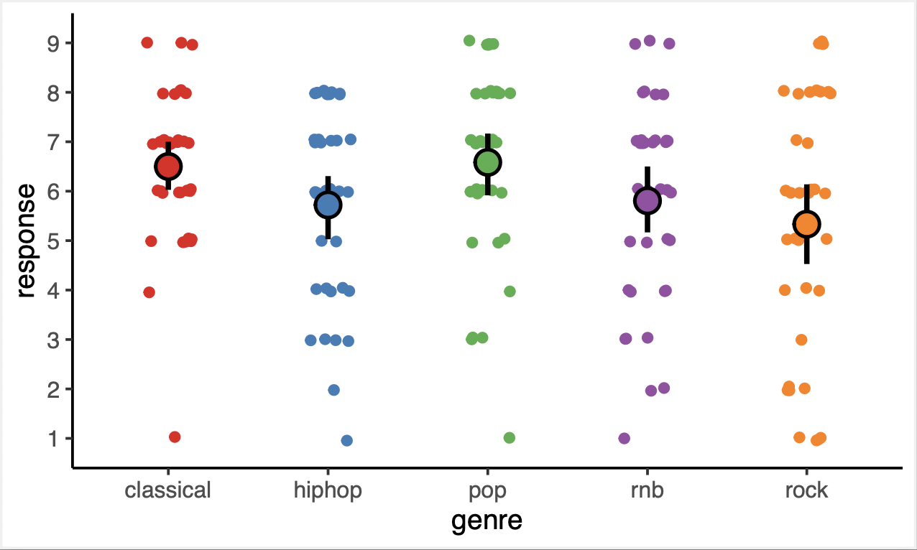

This plot shows that, across genres, pop music and classical music had the highest positive affect on subjects’ emotions with the average response at around 6.5, while, similar to McCarty’s findings, rock had the most negative impact on the emotions, averaging 5.5 for mood ratings.

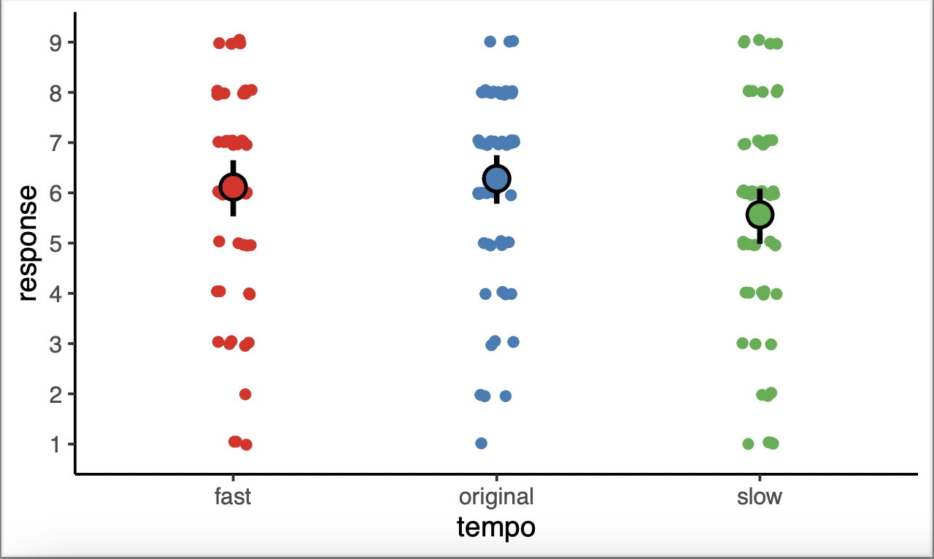

Solely based on the three different tempos, although the fast and original tempos have about the same effect on moods with the average response at somewhere between 6.1 to 6.5, the slow tempo has the most negative effect on emotions, averaging 5.7 for mood ratings.

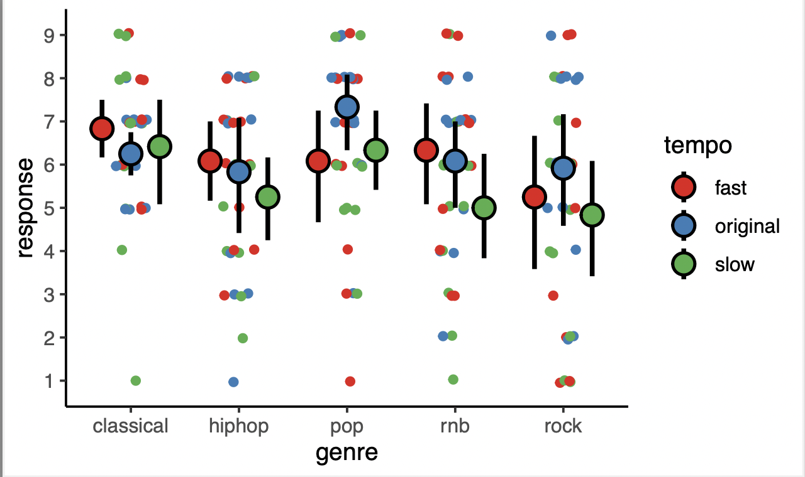

This overall plot shows that out of the fifteen recordings, pop music at its original tempo has the most positive impact on the subjects’ moods, while rock music at its 0.75x tempo has the most negative effect on emotions.

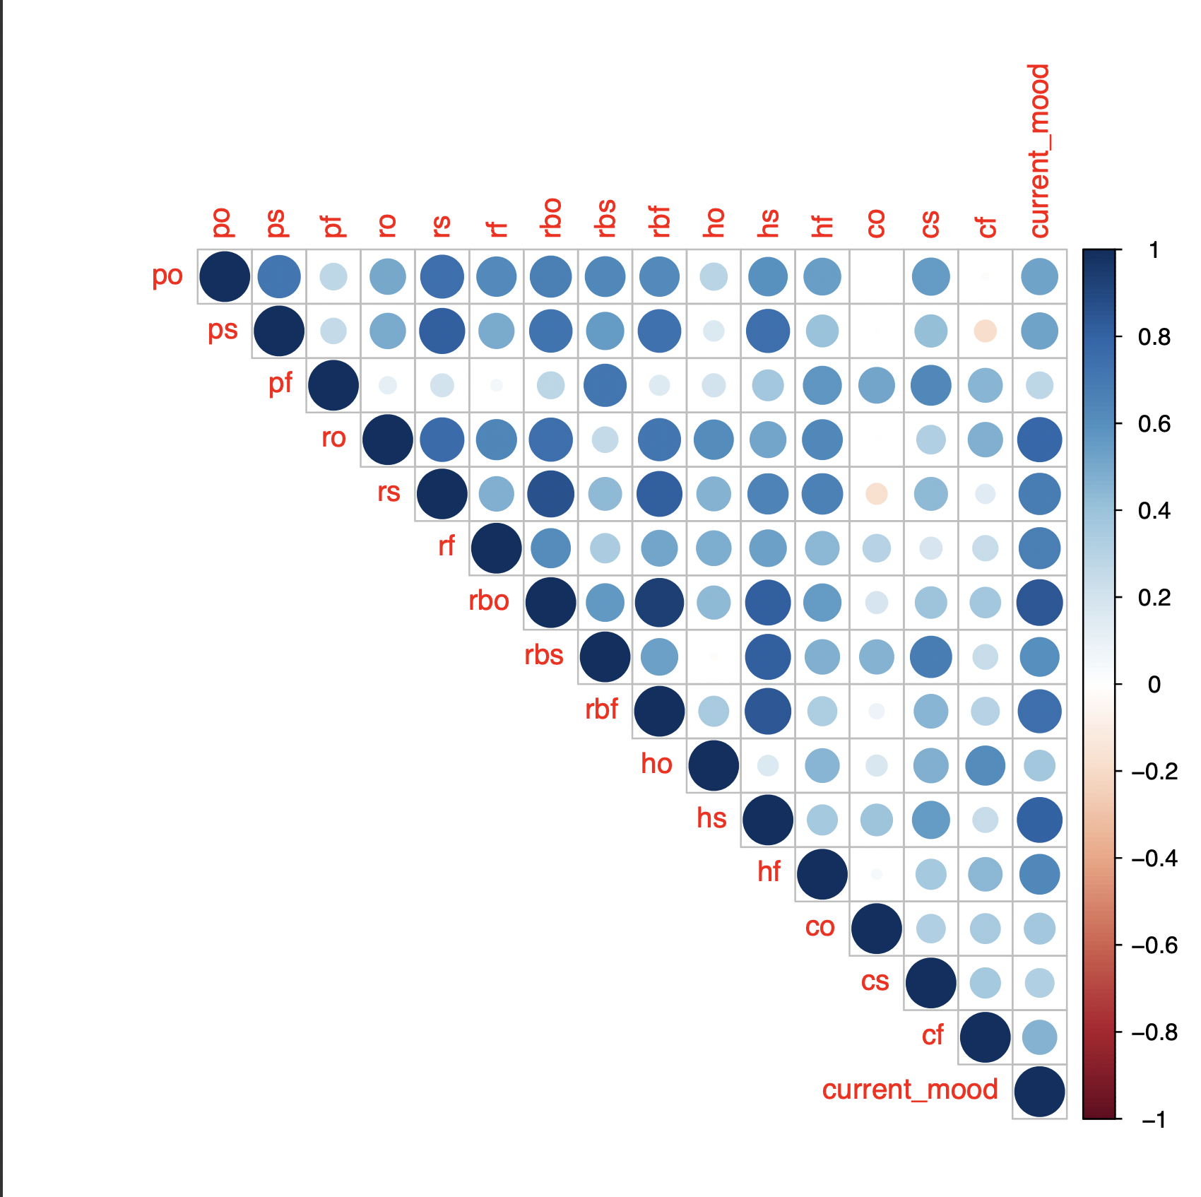

This correlation plot demonstrates that all the fifteen recordings are positively related to subjects’ original mood.

Based on the correlation plot, hypothesis 1 is supported. Solely looking at the current mood column on the right, all fifteen recordings more or less affect teenagers’ moods. Hypothesis 2 is disconfirmed as pop music at its original tempo has the most positive impact on the subjects’ moods with the average response at around 7.3. While rock music at 0.75x tempo had the most negative effect on emotions, averaging about 4.8, it could be said that hypothesis 3 is confirmed because the R&B music at its slowest tempo, being just barely higher in average mood ratings, had the second most negative effect on moods.

**Conclusion**

This research was set out to investigate how five different genres of music at diffferent tempos might affect teenagers’ moods. Pop music at its original tempo, surprisingly, had the most positive average response, and its average response for 1.25x tempo and 0.75x tempo seemed to be significantly different from that of its original tempo. It is possible that since pop music is the most popular genre of music (Clark 2021), subjects are more used to listening to its original speed and so when they are exposed to faster and slower tempos, it drews a more negative, or less positive, feeling.

Another thing worth noting is that the faster tempo for classical, hip-hop, and R&B music all had the most positive impact on emotions in their respective genre, while the slower tempo for hip-hop, R&B, and rock music had the most negative effects in each of their genres. With the findings in this study, perhpas we can more effectively use music therapy to treat patients by individualizing what music pieces at what tempo they should be treated with.

However, there are limitations on this study. The first being the sample size. Because the sample size is quite small, caution should be exercised in interpreting these results.Also, the music recordings might have been too short, being only 15 to 30 seconds long, and there was only one piece of music for each genre. It is possible that if subjects were to listen to multiple pieces in each genre of music at different tempos for a longer period of time, the effects of each clip on teenagers’ moods would be more obvious, or even different. Thus, future studies should address these shortcomings by amplifying the sample size, providing more music pieces in each genre, and making each clip longer.

**References**

Saarikallio, S. (2008). *Music in Mood Regulation: Initial Scale Development*, *7*, 291–309.

Chen, J. R. (2018). The impact of different genres of music on teenagers. *International Journal of Psychological Studies*, *10*(4), 42. https://doi.org/10.5539/ijps.v10n4p42

Clark, B. (2021, February 26). *The top 10 genres in the music industry*. Musician Wave. Retrieved August 7, 2022, from https://www.musicianwave.com/top-music-genres/

Garrido, S., & Schubert, E. (2013). Moody Melodies: Do they cheer us up? A study of the effect of SAD music on mood. *Psychology of Music*, *43*(2), 244–261. https://doi.org/10.1177/0305735613501938

Levitin, D., & Tirovolas, A. (2009). Current Advances in the Cognitive Neuroscience of Music. Retrieved August 7, 2022.

McCarty, R., Barrios-Chopin, B., Tomasino, D., & Atkinson, M. (1998). *The Effect of Different Types of Music on Mood, Tension, and Mental Clarity*, *4*, 75–84.

Substance Abuse and Mental Health Services Administration, C. for B. H. S. and Q. (2013, October). *Serious mental health challenges among older adolescents and young adults*. The CBHSQ Report: Serious Mental Health Challenges among Older Adolescents and Young Adults. Retrieved August 7, 2022, from https://www.samhsa.gov/data/sites/default/files/sr173-mh-challenges-young-adults-2014/sr173-mh-challenges-young-adults-2014/sr173-mh-challenges-young-adults-2014.htm

Thomson, C. J., Reece, J. E., & Di Benedetto, M. (2014). The relationship between music-related mood regulation and psychopathology in Young People. *Musicae Scientiae*, *18*(2), 150–165. https://doi.org/10.1177/1029864914521422